LOT  08550 | SDK;LAFDKL;  MKDSFLKDSMLSDL  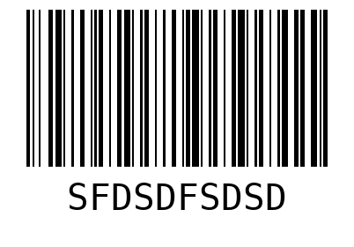  WO 01  LOT 08550  QTY 20

SHEET  1 | SDK;LAFDKL;  MKDSFLKDSMLSDL  WO 01  LOT 08550
SDK;LAFDKL;  MKDSFLKDSMLSDL  WO 01  LOT 08550 | SHEET  2
SDK;LAFDKL;  MKDSFLKDSMLSDL  WO 01  LOT 08550 | SDK;LAFDKL;  MKDSFLKDSMLSDL  WO 01  LOT 08550

SDK;LAFDKL;  MKDSFLKDSMLSDL  WO 01  LOT 08550 | SDK;LAFDKL;  MKDSFLKDSMLSDL  WO 01  LOT 08550
SDK;LAFDKL;  MKDSFLKDSMLSDL  WO 01  LOT 08550 | SHEET  3
SDK;LAFDKL;  MKDSFLKDSMLSDL  WO 01  LOT 08550 | SDK;LAFDKL;  MKDSFLKDSMLSDL  WO 01  LOT 08550

SDK;LAFDKL;  MKDSFLKDSMLSDL  WO 01  LOT 08550 | SDK;LAFDKL;  MKDSFLKDSMLSDL  WO 01  LOT 08550
SDK;LAFDKL;  MKDSFLKDSMLSDL  WO 01  LOT 08550 | SDK;LAFDKL;  MKDSFLKDSMLSDL  WO 01  LOT 08550
SDK;LAFDKL;  MKDSFLKDSMLSDL  WO 01  LOT 08550 | SDK;LAFDKL;  MKDSFLKDSMLSDL  WO 01  LOT 08550

SHEET  4 | SDK;LAFDKL;  MKDSFLKDSMLSDL  WO 01  LOT 08550
SDK;LAFDKL;  MKDSFLKDSMLSDL  WO 01  LOT 08550 | SDK;LAFDKL;  MKDSFLKDSMLSDL  WO 01  LOT 08550
SDK;LAFDKL;  MKDSFLKDSMLSDL  WO 01  LOT 08550 | SDK;LAFDKL;  MKDSFLKDSMLSDL  WO 01  LOT 08550

